Experiment: Artificial Neural Network using Backpropagation Algorithm
Aim
To build an Artificial Neural Network (ANN) by implementing the Backpropagation algorithm and test its performance using an appropriate dataset.
Procedure
- Import the required Python libraries such as NumPy, Pandas, Scikit-learn, and MLPClassifier.
- Load the dataset using the pandas.read_csv() function.
- Separate the dataset into input features (X) and target variable (y).
- Split the dataset into training and testing sets.
- Normalize or standardize the input data if required.
- Create an Artificial Neural Network (ANN) using the MLPClassifier.
- Train the ANN model using the Backpropagation algorithm.
- Test the trained model using the testing dataset.
- Predict the output for the test samples.
- Evaluate the model by calculating the accuracy and displaying the predicted results.
Python Program
import pandas as pd
from sklearn.datasets import load_iris
from sklearn.model_selection import train_test_split
from sklearn.neural_network import MLPClassifier
from sklearn.metrics import accuracy_score
# Load Iris dataset
iris = load_iris()
X = iris.data
y = iris.target
# Split dataset
X_train, X_test, y_train, y_test = train_test_split(
X, y, test_size=0.3, random_state=1
)
# Create ANN model
model = MLPClassifier(hidden_layer_sizes=(5,),
max_iter=1000,
random_state=1)
# Train model
model.fit(X_train, y_train)
# Predict
y_pred = model.predict(X_test
# Accuracy
print("Accuracy:", accuracy_score(y_test, y_pred))
print("\nActual Values:")
print(y_test)
print("\nPredicted Values:")
print(y_pred)
Output
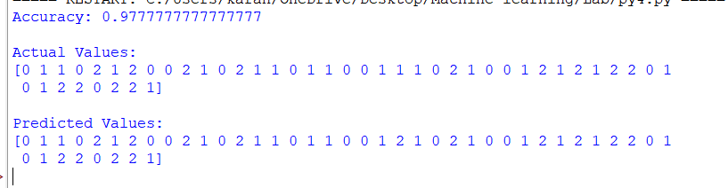
Result
The Artificial Neural Network (ANN) was successfully built using the Backpropagation algorithm. The trained model was tested on the dataset and produced accurate predictions with high classification accuracy.

